DFNUNIT-4
INTRODUCTION TO OPTICAL FIBERS AND TRANSMISSION CHARACTERISTICS

1(A) Briefly explain about optical fiber modes and configurations?

Optical Fiber Modes
🔷 What is a Mode?
A mode is a possible path (or pattern) in which light can propagate through the fiber core.
In simple terms, modes represent the different electromagnetic field distributions inside the fiber.
The number of modes supported by a fiber depends on:
- Core diameter
- Refractive index difference
- Operating wavelength

🔹 Types of Modes
1️⃣ Single Mode Fiber (SMF)
- Supports only one propagation mode.
- Core diameter ≈ 8–10 µm.
- Used for long-distance communication.
- High bandwidth.
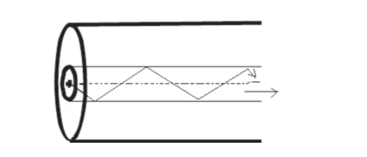

Characteristics:
- Light travels in nearly straight path.
- No intermodal dispersion.
- Used in high-speed systems (1550 nm region).

2️⃣ Multimode Fiber (MMF)
- Supports multiple propagation modes.
- Core diameter ≈ 50–100 µm.
- Used for short-distance communication.
- Higher dispersion due to multiple paths.
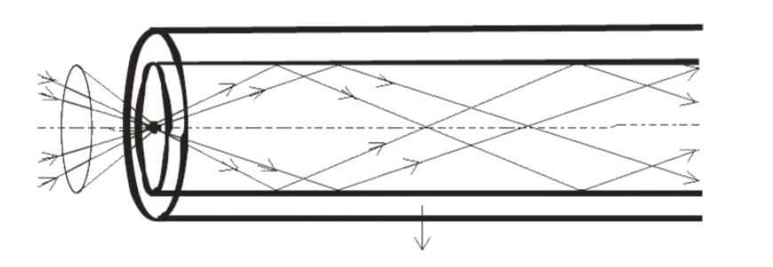

Optical Fiber Configurations
- Single-Mode Fiber (SMF): Features a very small core that allows only one mode of light to propagate, minimizing dispersion and attenuation for long-distance communication. Often categorized as OS1/OS2.

- Multimode Fiber (MMF): Features a larger core that allows multiple light modes to propagate, increasing dispersion. Common in data centers (OM1–OM5). 

- Step-Index Fiber: The refractive index of the core is uniform throughout, with a sharp, "step" decrease at the cladding interface. Used in both single-mode and multimode.
- Graded-Index Fiber: The refractive index of the core decreases gradually from the center axis, which reduces modal dispersion in multimode fibers.

- Material-Based Configuration:
  - Glass Optical Fiber (GOF): Silica-based, low-loss, suitable for long distances.
  - Plastic Optical Fiber (POF): Low-cost, durable, easier to install, used for short-range communication.

1(B) Explain the advantage of using graded index fibers.
Graded index (GRIN) fibers offer significantly higher bandwidth and lower signal distortion than multi-mode step-index fibers by minimizing intermodal dispersion.
Key advantages of using graded index fibers include:
- Reduced Intermodal Dispersion: The primary advantage is the dramatic reduction in time-of-flight differences between light modes, limiting signal pulse spreading.
- Higher Bandwidth/Data Rates: Due to lower distortion, they support higher data rates and greater information-carrying capacity over medium-distance, high-speed applications like local area networks (LANs) and data centers.
- Improved Efficiency in Multimode Transmission: Unlike step-index fibers, where light zig-zags, GRIN fibers allow light to travel in a smoother, helical, or sinusoidal path, reducing the tendency of signals to spread out.
- Optimal for Short/Medium Haul: They provide a cost-effective, high-performance solution for data transmission in commercial buildings, ships, and campus environments, acting as an intermediate solution between multimode step-index and single-mode fibers.
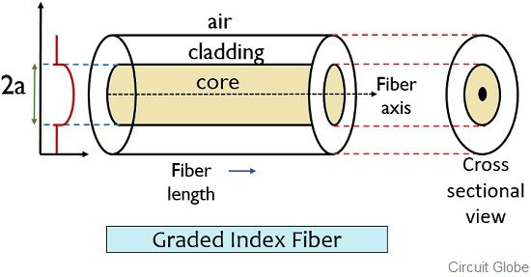

(2) Draw the block diagram of optical communication system and explain the function of each block.
An optical fiber communication system transmits information by converting electrical signals into light, guiding them through a fiber optic cable, and converting them back into electrical signals.

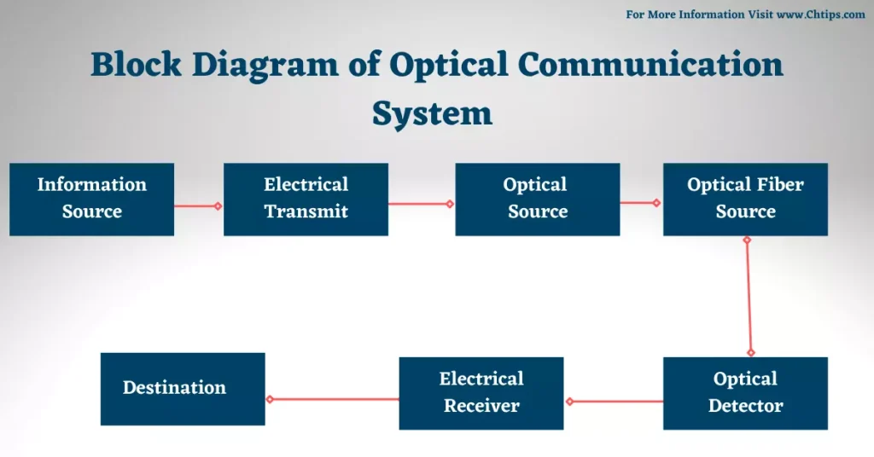
1️⃣ Information Source
The information source generates the message signal to be transmitted.
It may be:
- Analog signal (voice, music)
- Digital signal (computer data, binary information)
- Video signal
Example: Telephone conversation in fiber-optic telephone system.

2️⃣ Input Transducer
The input transducer converts the physical signal into an electrical signal.
Examples:
- Microphone → Sound to electrical signal
- Camera → Image to electrical signal
- Sensor → Physical quantity to electrical signal
If the source is already digital (like a computer), this stage may not be required.

3️⃣ Transmitter Section
The transmitter prepares the signal for optical transmission.
(a) Encoder
- Converts analog signal into digital form (if required).
- Performs line coding.
- May include multiplexing (TDM/WDM).
- Performs error control coding.
(b) Modulator
- Modulates the optical carrier.
- In most systems, Intensity Modulation (IM) is used.
- The light intensity varies according to the input signal.
(c) Driver Circuit
- Provides required current to the optical source.
- Ensures proper biasing of LED or Laser diode.
- Maintains stable optical output power.

4️⃣ Optical Source (LED / Laser Diode)
The optical source converts electrical signal into optical signal.

(a) LED (Light Emitting Diode)
- Used for short-distance communication.
- Less expensive.
- Wider spectral width.
- Lower power output.
(b) Laser Diode
- Used for long-distance and high data rate communication.
- Narrow spectral width.
- High power.
- High efficiency.
The wavelength commonly used:
- 850 nm
- 1300 nm
- 1550 nm (lowest attenuation region)
5️⃣ Optical Fiber Channel
- Medium through which light propagates.
- Made of core and cladding.
- Works on Total Internal Reflection principle.
- Advantages:
  - Low attenuation
  - High bandwidth
  - Immunity to electromagnetic interference
- May include:
  - Optical amplifiers
  - Repeaters (for long distance communication)

6️⃣ Optical Detector
The detector converts optical signal back into electrical signal.
Types:
- PIN Photodiode
- Avalanche Photodiode (APD)
Working Principle:
Based on Photoelectric Effect.
When light photons fall on the photodiode:
- Electron-hole pairs are generated.
- Current flows proportional to light intensity.
APD provides internal gain but is more complex.

7️⃣ Receiver Section
The receiver processes the weak electrical signal.
(a) Preamplifier
- Amplifies weak signal from photodiode.
- Improves signal-to-noise ratio.
(b) Filter
- Removes noise components.
- Improves signal clarity.
(c) Demodulator
- Extracts original baseband signal.
(d) Decoder
- Removes coding.
- Performs error correction.

8️⃣ Output Transducer
Converts electrical signal back to original form.
Examples:
- Speaker (electrical → sound)
- Monitor (electrical → visual signal)

9️⃣ Destination
The final user or receiving system.
Examples:
- Telephone receiver
- Computer
- Television

3(A) Explain the signal distortion in optical waveguide
Introduction
Signal distortion in an optical waveguide (optical fiber) refers to the spreading of an optical pulse as it propagates along the fiber. This spreading causes overlapping of adjacent pulses, leading to Inter-Symbol Interference (ISI) and limits the bandwidth and transmission distance of an optical communication system.

Causes of Signal Distortion
Signal distortion in optical fibers mainly occurs due to dispersion. Dispersion means different components of a light pulse travel at different speeds inside the fiber.
Dispersion is classified into:
- Intermodal Dispersion (Modal Dispersion)
- Intramodal Dispersion (Chromatic Dispersion)
  - Material Dispersion
  - Waveguide Dispersion

1. Intermodal Dispersion
- Occurs in multimode fibers.
- Different modes (rays) travel different path lengths.
- Rays traveling along the axis reach earlier than those taking zig-zag paths.
- This causes pulse broadening at the output.
👉 Effect: Severe pulse spreading
👉 Remedy:
- Use graded-index fiber 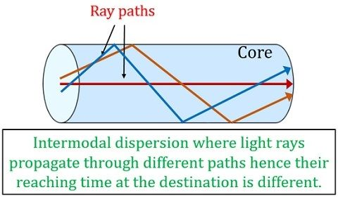
- Use single-mode fiber

2. Intramodal Dispersion (Chromatic Dispersion)
Occurs even in single-mode fibers because a light source emits a range of wavelengths.
(a) Material Dispersion
- Refractive index of the fiber material varies with wavelength.
- Different wavelengths travel at different velocities.
- Leads to pulse spreading.
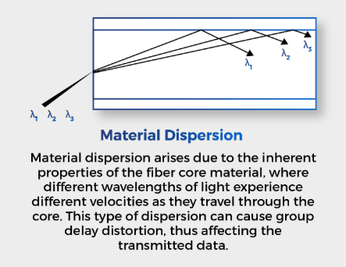
(b) Waveguide Dispersion
- Due to the fiber structure.
- Light energy travels partly in core and partly in cladding.
- Different wavelengths distribute differently between core and cladding.
👉 Total chromatic dispersion = Material dispersion + Waveguide dispersion
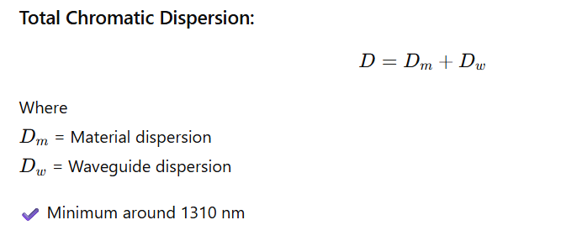
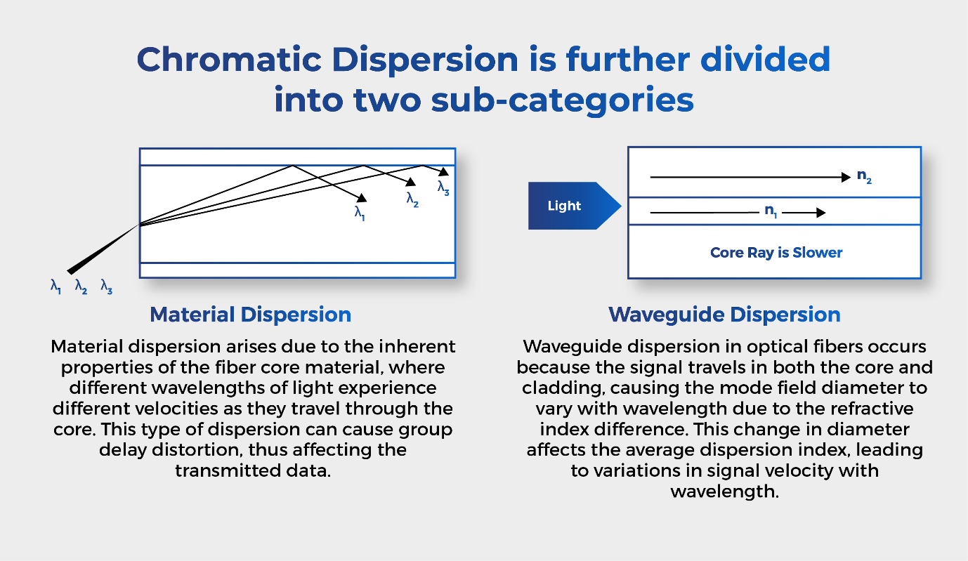

4. Effects of Signal Distortion
- Pulse broadening
- Inter-symbol interference (ISI)
- Reduced signal quality
- Limited bandwidth

5. Methods to Reduce Signal Distortion
- Use single-mode fibers
- Use laser sources instead of LEDs
- Employ dispersion compensation techniques
3(B) Explain the mechanisms of attenuation losses in OF.
1. Introduction
Attenuation in an optical fiber refers to the reduction in optical power as light propagates through the fiber. It limits the transmission distance and is expressed in dB/km.
Attenuation occurs mainly due to three mechanisms:

2. Material Absorption Loss
Absorption loss occurs when part of the optical energy is converted into heat inside the fiber material.
It is of two types:
(a) Intrinsic Absorption
- Due to fundamental properties of silica material.
- Caused by electronic absorption (UV region) and molecular vibration (IR region).

(b) Extrinsic Absorption
- Due to impurities such as OH⁻ ions and metal ions present in the fiber.
- Produces absorption peaks, especially around 1.38 µm.

3. Scattering Loss
Scattering occurs due to microscopic variations in the refractive index.
(a) Rayleigh Scattering
- Main scattering loss in optical fibers.
- Caused by small density and compositional fluctuations.
- More significant at shorter wavelengths (∝ 1/λ⁴).
(b) Mie Scattering
- Caused by core-cladding irregularities and structural defects.

4. Bending Loss
Occurs when the fiber is bent.
(a) Macrobending Loss
- Due to large bends in the fiber.
- Causes light to radiate out of the core.
(b) Microbending Loss
- Due to small, microscopic bends caused during manufacturing or cabling.

4. What are the two types of Bending losses. Explain with sketches
1. Introduction
Bending losses occur in an optical fiber when the fiber is curved or bent, causing part of the guided light to escape from the core into the cladding. These losses increase attenuation and reduce signal strength.
Bending losses are classified into:
- Macrobending Loss
- Microbending Loss

2. Macrobending Loss
Definition
Macrobending loss occurs when the optical fiber is bent with a large visible radius of curvature.
Cause
- When the bend radius becomes too small, the angle of incidence of light at the core-cladding interface decreases.
- Some light rays fail to satisfy the condition of total internal reflection.
- Light radiates out of the core into the cladding and is lost.
Characteristics
- Visible bend in fiber
- More significant in single-mode fibers
- Increases rapidly when bend radius decreases
- Depends on wavelength and refractive index difference
(When fiber is sharply bent, light leaks out.)

3. Microbending Loss
Definition
Microbending loss occurs due to very small, microscopic bends or distortions along the fiber axis.
Cause
- Caused by manufacturing defects
- Mechanical pressure during cabling
- Temperature variations
- Uneven surfaces
These tiny bends cause mode coupling and radiation loss.
Characteristics
- Not visible to the naked eye
- Causes scattering of light
- Occurs along the length of the fiber
- Can degrade signal gradually
5. Write detailed notes on core and cladding losses.
In an optical fibre, attenuation (loss of optical power) occurs as light propagates through the fibre. These losses are broadly classified into:
- Core losses
- Cladding losses
Understanding these losses is important for designing high-performance optical communication systems.

1️⃣ Core Losses
Core losses occur due to imperfections and physical phenomena inside the core region of the optical fibre where light propagates.
A) Absorption Loss
Absorption converts optical energy into heat.
(i) Intrinsic Absorption
- Caused by the fundamental properties of the fibre material (usually silica).
- Due to electronic absorption in UV region.
- Due to vibrational absorption in IR region.
✔Unavoidable
✔ Determines transmission windows (850 nm, 1310 nm, 1550 nm)

(ii) Extrinsic Absorption
- Caused by impurities in the fibre material.
- Metallic ions (Fe, Cu, Cr)
- Hydroxyl (OH⁻) ions (water impurities)
✔Can be minimized by purification
✔ Major cause of loss in early fibers

B) Scattering Loss
Scattering causes light to deviate from its original path.
(i) Rayleigh Scattering
- Caused by microscopic density and refractive index fluctuations.
- Dominant loss in modern optical fibers.
- Loss ∝ 1 / λ⁴ (decreases with increasing wavelength)
✔ Main reason for operating at 1310 nm and 1550 nm

(ii) Mie Scattering
- Caused by structural irregularities.
- Core-cladding interface imperfections.
- Bubbles or diameter variations.
✔ Reduced by improved manufacturing

C) Bending Loss (Core Related)
When fibre is bent, some guided light escapes.
(i) Macro bending Loss
- Caused by large visible bends.
- Radiation of light outside the core.
(ii) Micro bending Loss
- Caused by microscopic distortions.
- Results from pressure or manufacturing defects.

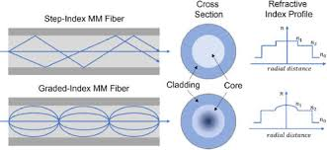

2️⃣ Cladding Losses
Cladding losses occur when light escapes from the core into the cladding region and is not properly guided.

A) Improper Total Internal Reflection
- If the angle of incidence becomes less than the critical angle,
- Light refracts into the cladding.
✔ Caused by poor fibre design or bending

B) Leaky Modes
- Some modes are not completely confined.
- Light gradually leaks into the cladding.

C) Cladding Absorption
- If cladding material absorbs leaked light,
- Optical power reduces further.

D) Poor Splicing and Connectors
- Misalignment between cores
- Core-cladding mismatch
- Air gaps
✔Causes coupling loss
✔ Light enters cladding instead of core

6. Write short notes on Signal degradation in optical fibers.
1. Introduction
Signal degradation in optical fibers refers to the deterioration of signal quality as light propagates through the fiber. It results in reduction of signal strength, distortion of pulses, and increased bit error rate (BER). Signal degradation limits transmission distance and system performance in optical communication systems.

2. Causes of Signal Degradation
Signal degradation mainly occurs due to:
- Attenuation
- Dispersion
- Nonlinear Effects
- Noise

3. Attenuation
Attenuation is the reduction in optical power as light travels through the fiber. It is measured in dB/km.
It is caused by:
- Material absorption
- Scattering losses
- Bending losses
Effect: Weakens the signal and requires optical amplifiers or repeaters for long-distance communication.

4. Dispersion
Dispersion causes pulse broadening because different components of light travel at different speeds.
Types of dispersion:
- Modal dispersion (in multimode fibers)
- Chromatic dispersion (material + waveguide dispersion)
- Polarization mode dispersion (PMD)
Effect: Causes inter-symbol interference (ISI) and limits bandwidth.

5. Nonlinear Effects
At high optical power levels, nonlinear phenomena occur in the fiber.
Important nonlinear effects include:
- Self-phase modulation (SPM)
- Cross-phase modulation (XPM)
- Four-wave mixing (FWM)
- Stimulated Raman and Brillouin scattering
Effect: Distorts signal and limits high-speed, long-distance transmission.

6. Noise
Noise degrades signal quality and affects receiver performance.
Main noise sources:
- Thermal noise
- Shot noise
- Amplifier noise (ASE noise in optical amplifiers)
Effect: Reduces signal-to-noise ratio (SNR) and increases BER.

7. Effects of Signal Degradation
- Pulse broadening
- Reduced bandwidth
- Increased BER
- Limited transmission distance
- Poor system reliability

8. Methods to Reduce Signal Degradation
- Use single-mode fibers
- Operate at low-loss windows (1.3 µm and 1.55 µm)
- Use dispersion compensation techniques
- Use optical amplifiers
- Maintain proper installation practices

7. Describe the Scattering losses and absorption losses of OF signal.
Core Losses
Core losses occur due to imperfections and physical phenomena inside the core region of the optical fibre where light propagates.
A) Absorption Loss
Absorption converts optical energy into heat.
(i) Intrinsic Absorption
- Caused by the fundamental properties of the fibre material (usually silica).
- Due to electronic absorption in UV region.
- Due to vibrational absorption in IR region.
✔Unavoidable
✔ Determines transmission windows (850 nm, 1310 nm, 1550 nm)

(ii) Extrinsic Absorption
- Caused by impurities in the fibre material.
- Metallic ions (Fe, Cu, Cr)
- Hydroxyl (OH⁻) ions (water impurities)
✔Can be minimized by purification
✔ Major cause of loss in early fibers

B) Scattering Loss
Scattering causes light to deviate from its original path.
(i) Rayleigh Scattering
- Caused by microscopic density and refractive index fluctuations.
- Dominant loss in modern optical fibers.
- Loss ∝ 1 / λ⁴ (decreases with increasing wavelength)
✔ Main reason for operating at 1310 nm and 1550 nm

(ii) Mie Scattering
- Caused by structural irregularities.
- Core-cladding interface imperfections.
- Bubbles or diameter variations.
✔ Reduced by improved manufacturing

8. Write short notes on ray optics and explain the propagation of optical ray in OF.
Short Notes on Ray Optics
Ray optics (also called geometrical optics) is the branch of optics that describes the propagation of light in terms of rays. It is valid when the wavelength of light is much smaller than the dimensions of the optical components.
Basic Principles of Ray Optics
- Rectilinear Propagation of Light
Light travels in straight lines in a homogeneous medium.
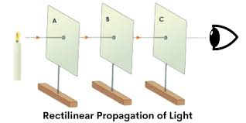
- Reflection
When light strikes a surface, it is reflected according to the laws of reflection:
  - Angle of incidence = Angle of reflection
  - Incident ray, reflected ray, and normal lie in the same plane.
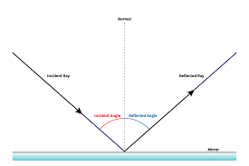
- Refraction (Snell’s Law)
When light passes from one medium to another, it bends according to:
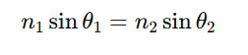
where n1​,n2​ are refractive indices.

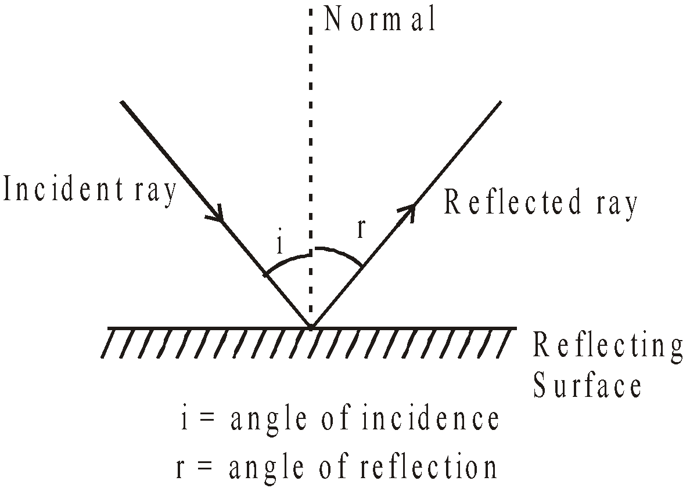

Total Internal Reflection (TIR)
When light travels from a denser medium to a rarer medium and the angle of incidence exceeds the critical angle, it is completely reflected back.
Ray optics is widely used in analyzing optical fibers, lenses, mirrors, and imaging systems.
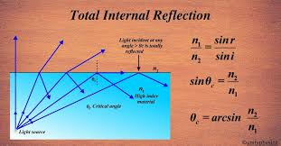

Propagation of Optical Ray in Optical Fiber (OF)
Optical fiber works on the principle of Total Internal Reflection (TIR).
An optical fiber consists of:
- Core (refractive index n1)
- Cladding (refractive index n2​), where n1>n2​
Condition for Propagation
For light to propagate through the fiber:
- Light must enter the fiber within a certain angle called the acceptance angle.
- Inside the core, the angle of incidence at the core–cladding interface must be greater than the critical angle.
Step-by-Step Propagation
- A light ray enters the fiber core from air.
- It refracts at the air–core interface.
- If the internal angle is greater than the critical angle, it undergoes Total Internal Reflection at the core–cladding boundary.
- The ray reflects repeatedly along the length of the fiber.
- Thus, the light is guided through the fiber with very low loss.
Numerical Aperture (NA)
The light-gathering capacity of a fiber is given by:
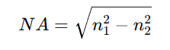

9. How to you determine the information carrying capacity of optical fibre?
The information carrying capacity of an optical fiber refers to the maximum amount of data that can be transmitted through the fiber per second without significant distortion. It mainly depends on the bandwidth of the fiber.
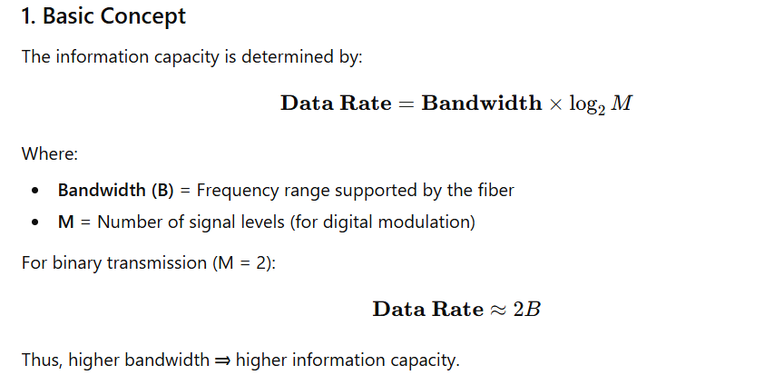
2. Factors Affecting Bandwidth of Optical Fiber
(a) Modal Dispersion
Occurs in multimode fibers due to different paths taken by light rays.
More dispersion ⇒ Lower bandwidth.
(b) Chromatic Dispersion
Occurs because different wavelengths travel at different speeds.
(c) Material Dispersion
Variation of refractive index with wavelength.
(d) Waveguide Dispersion
Due to fiber structure and refractive index profile.
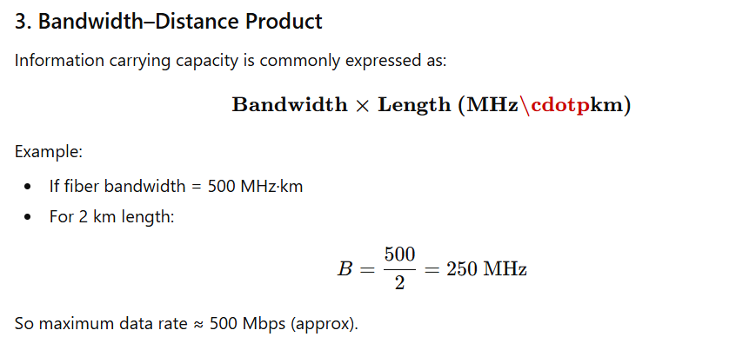
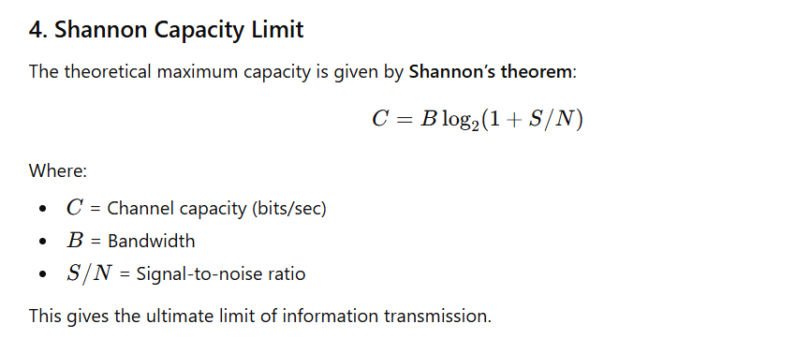
5. Comparison of Fibers
- Multimode Step Index Fiber → Low capacity (high modal dispersion)
- Multimode Graded Index Fiber → Moderate capacity
- Single Mode Fiber → Very high capacity (no modal dispersion)
Single mode fibers are used in long-distance and high-speed communication systems.

10. With a neat sketch explain the waveguide dispersion phenomenon
Waveguide dispersion is the pulse broadening in an optical fiber that occurs due to the dependence of propagation constant (or group velocity) on wavelength because of the fiber’s core–cladding structure, even when the material dispersion is negligible.
It is significant mainly in single-mode fibers.
Neat Sketch
(1) Field Distribution in Core and Cladding
In an optical fiber (especially single-mode fiber), the electromagnetic field is not completely confined to the core. Instead, it is:
- Maximum at the center of the core
- Gradually decreases toward the core–cladding boundary
- Extends slightly into the cladding (evanescent field)
- Decays exponentially inside the cladding

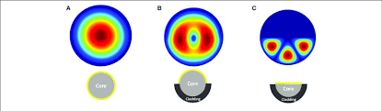
(2) Pulse Broadening Due to Waveguide Dispersion
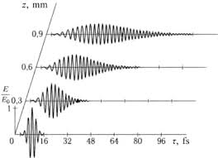
Explanation of Waveguide Dispersion
In a single-mode fiber:
- Light propagates as a fundamental mode.
- The optical field is not completely confined to the core.
- A portion of energy travels in the cladding.
- The fraction of power in core and cladding depends on wavelength (λ).

Important Points:
- For shorter wavelengths:
  - More power is confined inside the core.
  - Effective refractive index is closer to core index.
  - Light travels slightly slower.
- For longer wavelengths:
  - More power spreads into cladding.
  - Effective refractive index decreases.
  - Light travels slightly faster.
Because different wavelength components travel at different group velocities, the pulse spreads → this is waveguide dispersion.

Mathematical Expression
Total dispersion in single-mode fiber:
D=Dm+Dw​
Where:
- Dm​ = Material dispersion
- Dw​ = Waveguide dispersion
Waveguide dispersion depends on:
- Core radius (a)
- Refractive index difference (Δ)
- Operating wavelength (λ)

Characteristics
- Significant in single-mode fibers
- Can be engineered by adjusting core radius and refractive index profile
- Used to shift zero-dispersion wavelength (e.g., around 1.55 µm in modern fibers)

